Instructions for Joining the Future-BME 2026 Microsoft Teams Conference

Before the Meeting
- Install Microsoft Teams (Optional but Recommended):
  - You can download Microsoft Teams for Windows/macOS here.
  - If you do not want to install Teams, you can still join the meeting via your web browser (Google Chrome, Microsoft Edge, etc...).
- Prepare Your Equipment:
  - Ensure you have a working microphone, webcam, and stable internet connection.
  - Use headphones to avoid echo or feedback.

Joining the Meeting
- Click the Meeting Link:
  - Click on the Teams meeting link provided (e.g., via email, schedule, website or calendar invite).
  - Example:
https://teams.microsoft.com/l/meetup-join/xxxxxxxxxxxxxxxxxxxxxxxxx
- Choose How to Join:
- You will be prompted to:
  - Continue on this browser (to join the meeting in the web browser),
  - Join in the Teams app (to join the meeting in the MS Teams app),
  - Download the app.
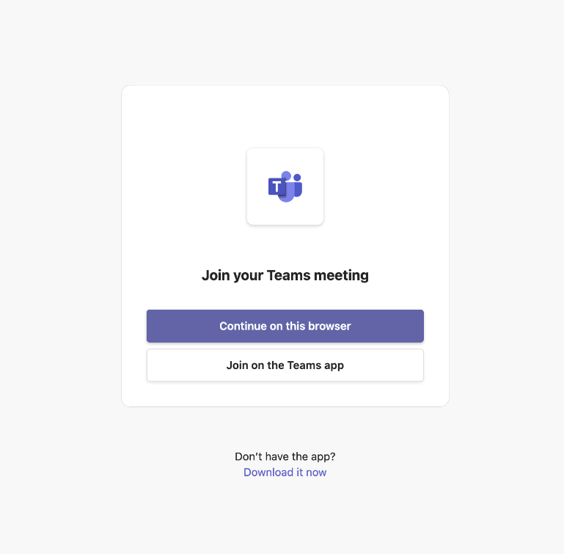
- Allow MS Teams web application to use your microphone and camera
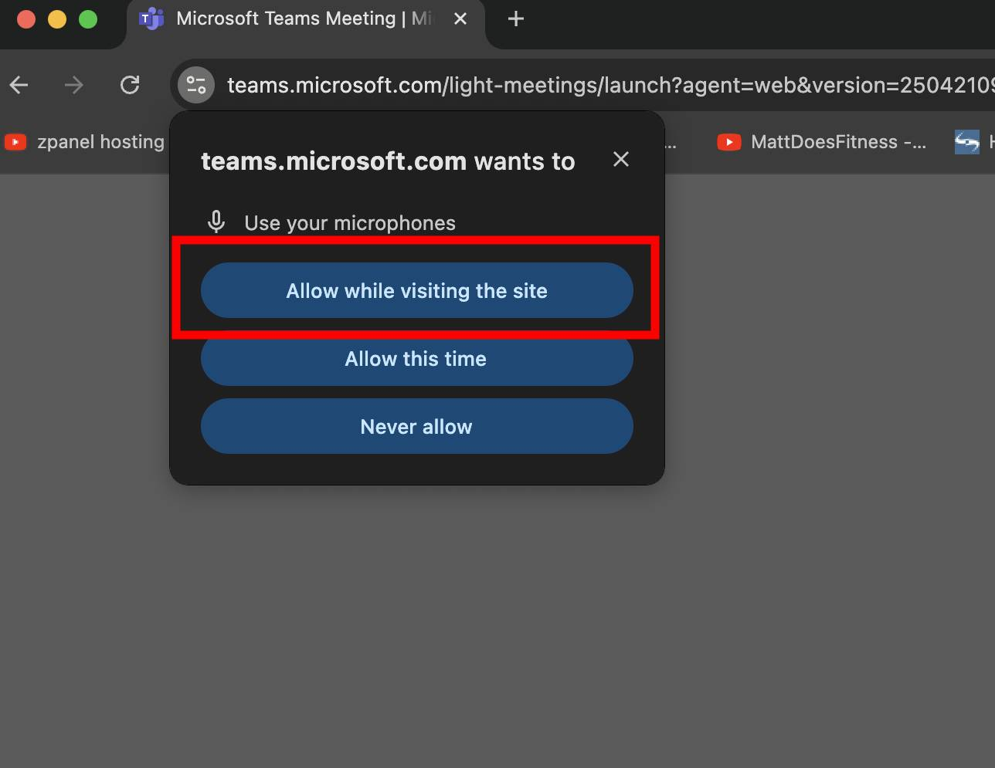
- Enter Your Name: If you’re joining via browser and not signed in, enter your full name (e.g., Dr. John Smith – University of X).

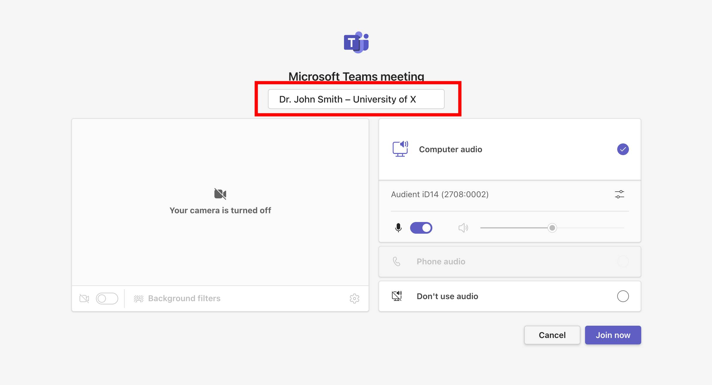
5. Mute your microphone before joining.
- You may choose to turn your camera on or off.

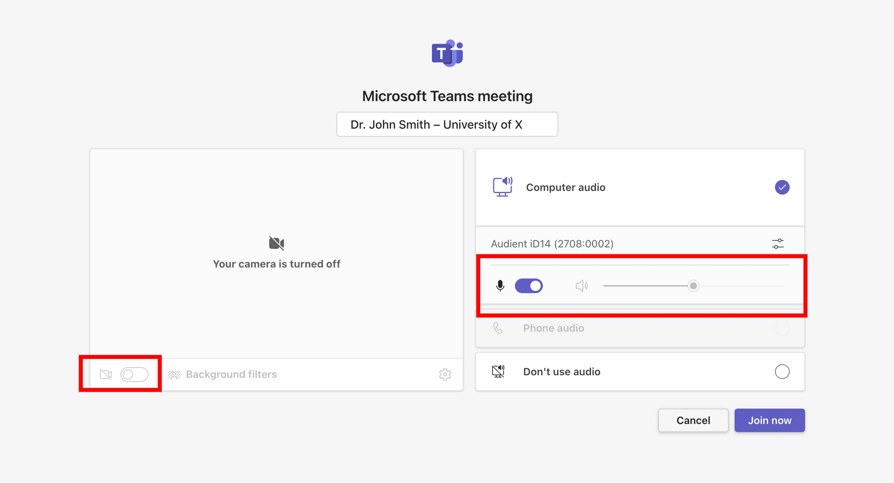

6. Click "Join Now":
  - You will be admitted directly or placed in the lobby until the meeting admin allows you in.

Features and Best Practices for Attendees

1. Meeting Lobby
- Some users may be placed in a virtual lobby until the organizer admits them.
- Please wait patiently if you're not admitted immediately.

2. Roles in Teams Meetings
- Attendees: Can view and listen, raise hands, use chat.
- Presenters: Can share screen, speak freely, admit others, and manage the meeting.
- Meeting Admins: Will follow the schedule and promote designated attendees to Presenters when it is their turn to present.

3. Meeting Toolbar
Located at the top/bottom of your screen.
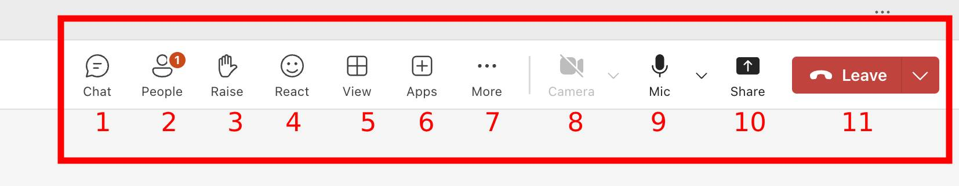
- Chat: Open the meeting chat panel.
- People: See who’s in the meeting.
- Raise Hand: Indicate you wish to speak.
- React: Give reaction.
- View: Change how people are presented in the meeting.
- Apps: Add applications if you have the permission.
- ⋯ More Options: Change device settings, view full screen, turn on live captions, etc.
- Camera: Start/stop your video.
- Microphone: Mute/unmute yourself.
- Share: Only available to Presenters.
- Leave: Leave the meeting.

4. Sharing the presentation
- Click the Share Button - In the meeting toolbar at the top-right corner, click the Share icon as shown in the image.
- Choose Your Sharing Option - After clicking “Share”, a panel will open on the right side. You’ll see several options under “Share”.
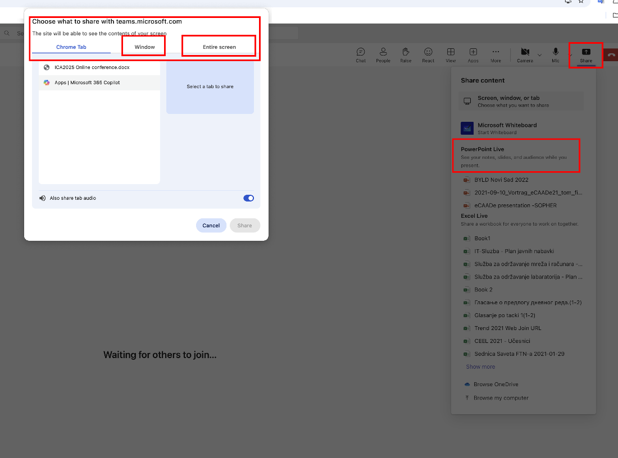
- Screen, window, or tab
Opens a dialog where you can choose exactly what to share:
  - Entire screen – Shows everything on your desktop.
  - Window – Shares just one specific app (e.g., PowerPoint or Word).
  - Browser tab – Share a specific browser tab (great for online demos).
- PowerPoint Live
Upload and present a PowerPoint file directly in Teams.

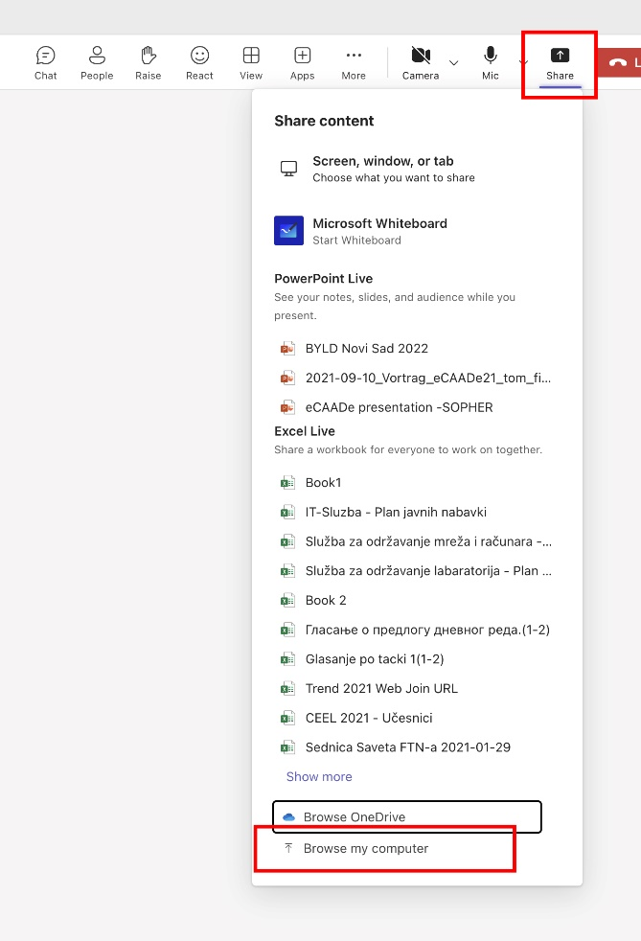
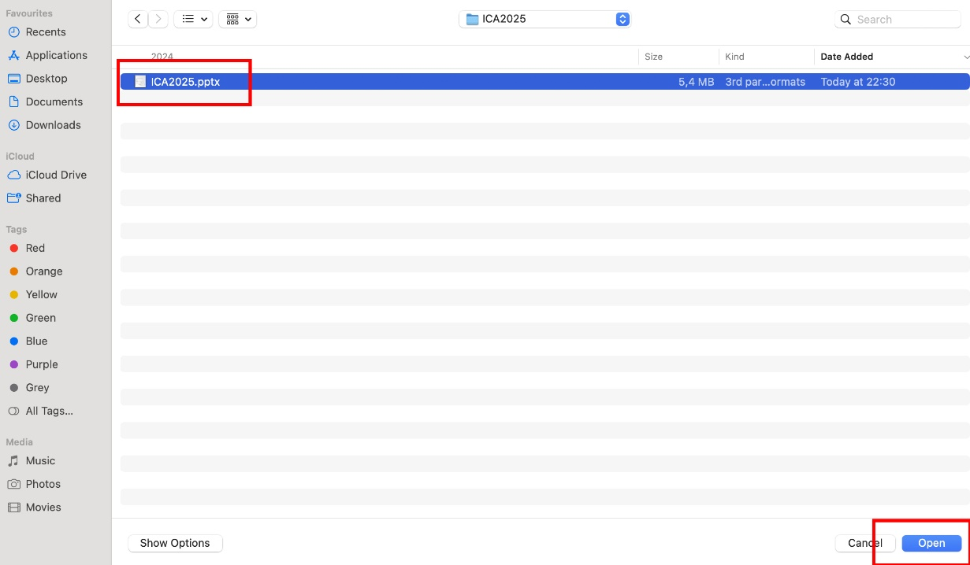
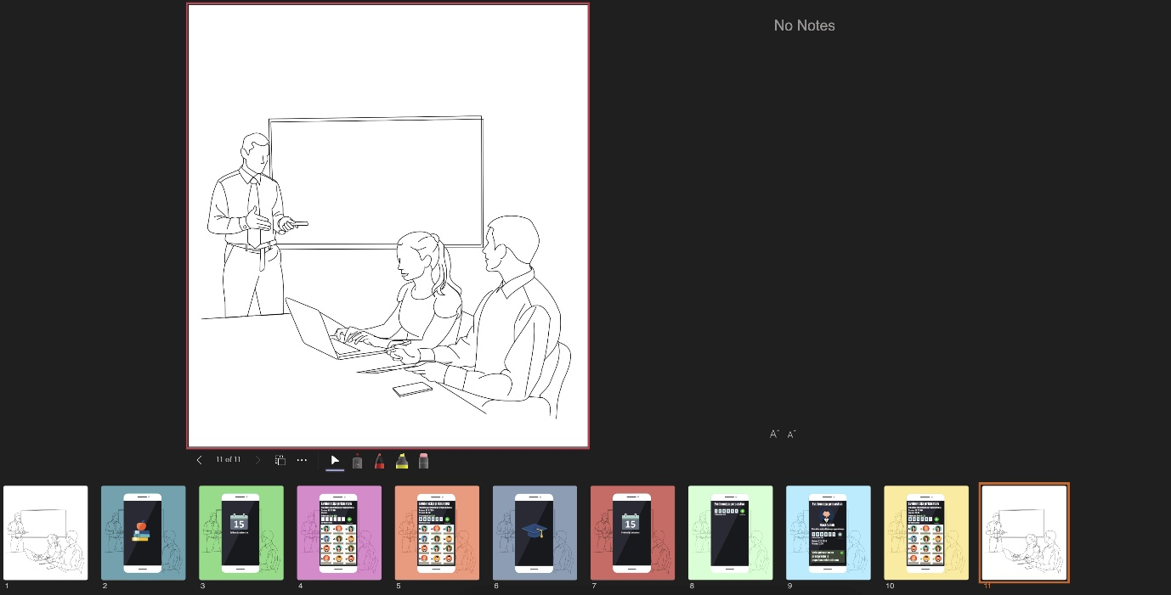

Allows you to:
  - Use presenter notes
  - Let audience move through slides independently
  - Seamlessly control your deck
This is highlighted on the right side of your screenshot in the share panel.
- Share Audio (Optional)
If you're sharing a video or audio clip, toggle “Also share tab audio” (as seen at the bottom left of the screenshot).
This ensures everyone hears the sound from your computer.
- Click Share
Once you’ve selected the content, click the "Share" button in the dialog box (bottom-right). Your shared screen or content will become visible to all participants.
- Stop Sharing
To stop sharing, click the “Stop sharing” button (a red square) in the meeting control bar at the top of your screen.

Meeting Chat
- Use the chat panel to ask questions, share links, or make comments.
- Be respectful and clear.
- Admins may moderate the chat if needed.

Raise Hand
- Use the Raise Hand feature to indicate you would like to speak.
- Wait for the moderator or presenter to acknowledge you.

Screen Sharing
- Only Presenters can share screens, PowerPoint files, or whiteboards.
- If you are presenting, wait for the admin to promote you to Presenter before attempting to share.

Reactions (Optional)
- Use emojis to react to speakers without interrupting.

